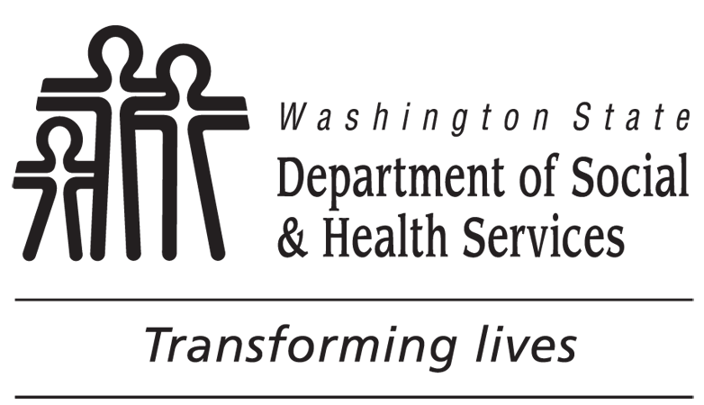 | STATE OF WASHINGTON  DEPARTMENT OF SOCIAL AND HEALTH SERVICES  BACKGROUND CHECK CENTRAL UNITE (BCCU)  (360) 902-0299  List of Additional Crimes or Pending Charges
This form MUST be attached to the Background Check Authorization form, DSHS 09-653.
Important information about answering self-disclosure questions: Your answers to self-disclosure questions become part of your background check history and are stored in the DSHS database. It is important that your answers to self-disclosure questions are accurate and consistent. It is strongly recommended that you answer self-disclosure questions the same way each time you complete the Background Check Authorization form unless the question has changed or the previous answer was wrong. It is also recommended that you refer to charging papers, court records, or other official documents and that you list criminal convictions, pending charges, dates and other information exactly as they are listed in those documents.
REQUIRED: PRINT YOUR NAME AS IT IS LISTED ON YOUR DRIVER’S LICENSE OR OTHER PHOTO ID.
FIRST: |  | MIDDLE: |  | LAST:
REQUIRED: DATE OF BIRTH (MM/DD/YYYY)

11A. If you check YES, you must enter the crime name, degree (if any), state, and the conviction date (MM/DD/YYYY).
Crime Name |  |  | Degree (if any) | State | Conviction Date (MM/DD/YYYY)
11B. If you check YES, you must enter the pending charge name, degree (if any), and state.
Crime Name |  |  |  | Degree (if any) | State

